**South Carolina Prescribed Fire Council Annual Meeting  
September 26-27, 2017 – Hartsville, SC**

This is a 1.5 day workshop. The first day will be an afternoon field tour of private and public lands in and near the Carolina Sandhills National Wildlife Refuge. The field trip will begin at 2:00 pm on the refuge, at Lake Bee Recreation Area (located on SC Highway 145, 6.2 miles north of US Highway 1: **Latitude:** 34.5773 **Longitude:** -80.2361). We need to carpool to reduce the number of vehicles on the field trip. The field trip will return to Lake Bee at 4:30 pm, and the social will begin, with a sponsored catered meal being served at 5:00 pm.

The second day will be held at the Lakeview Country Club in Hartsville with registration beginning at 8:30 am and the program starting at 9:00 am. This will be a classroom format, and a sponsored lunch will be served. ​Individuals can register for Day 1 ($25), Day 2 ($45) or Both Days ($70).  Reduced pricing available to landowners.

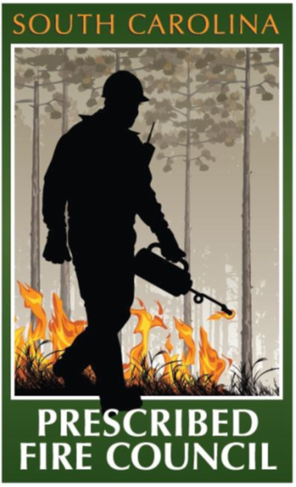For questions please contact **Derrick Phinney**, [dphinne@clemson.edu](mailto:dphinne@clemson.edu) or 843-563-0135 ext. 3

Please visit [www.SCPFC.net](http://www.SCPFC.net) for more information.

**Direct Registration link below:** <https://tickets2017scpfc.eventbrite.com/>

**DAY 1: SEPTEMBER 26, 2017**

**Field Tour – Carolina Sandhills National Wildlife Refuge | 23734 U.S. Highway 1, McBee, SC 29101**

Noon – Lunch on your own

1:30 pm – Meet at Carolina Sandhills Refuge Lake Bee  
**Latitude:** 34.5773 **Longitude:** -80.2361

2:00 pm – Depart for field tour on private and public lands

4:30 pm – Return to Lake Bee for social

Evening Social and Dinner

5:00 pm – Lake Bee, located on the Carolina Sandhills National Wildlife Refuge

**Latitude:** 34.5773 **Longitude:** -80.2361

The following organizations are represented on the SC Prescribed Fire Council Steering Committee

          Plantation Managers
 Association 



**South Carolina Prescribed Fire Council Annual Meeting**

**September 26-27, 2017 – Hartsville, SC**

**Day 2: September 27, 2017**

Registration starts at 8:30 am

**Lakeview Country Club**

**401 Springwood Dr  
Hartsville, SC 29550**  
**Latitude**: 34.3690 | **Longitude**: -80.1186

8:30 Registration

9:00 SC Prescribed Fire Council Updates  
 Tom Dooley, Chair – SC Prescribed Fire Council  
 The Nature Conservancy

9:10 Engaging Private Landowners and Longleaf Implementation Team Involvement  
 Charles Babb  
 The Sandhills Longleaf Pine Conservation Partnership

9:45 Pulling Together a Tree Farm, Piece by Piece: Private Landowner Experiences  
 Randall Ewing  
 Landowner

10:00 Reintroducing Fire into Unburned Longleaf Stands  
 Tom Dooley  
 The Nature Conservancy

10:30 Break

11:00 Balancing Prescribed Fire and Pine Straw Production  
 Brain Davis  
 South Carolina Forestry Commission

11:30 New Public Outreach, Research, and Learning Opportunities Since the 2016 Southern Appalachian Wildfires  
 Helen Mohr  
 US Forest Service

12:00 Lunch

1:00 Recognizing and Controlling Invasives   
 Jimmy Walters  
 Urban Forest Advisors, LLC

1:30 Prescribed Fire: A Private Landowner's Experience  
 Boon Chesson  
 Private Landowner

2:00 Bringing Back the Whistle: Burning on Private Lands  
 Susan Sullivan  
 SCDNR – Farm Bill Biologist

2:25 NBCI Fire Bird Award

Michael Hook

South Carolina Department of Natural Resources

2:30 Prescribed Fire Accomplishments & Certification in South Carolina  
 Darryl Jones  
 South Carolina Forestry Commission

3:00 County Fire Resolutions  
 Tom Dooley  
 The Nature Conservancy

3:10 Evaluations and Wrap-up

3:15 Dismissal

**Forestry CFEs:**

Day 1: 1.0 hr Cat. 1

Day 2: 3.5 hrs Cat. 1

Registration closes on September 22, 2017. Online registration is preferred but for additional options or questions please contact: **Derrick Phinney** at [dphinne@clemson.edu](mailto:dphinne@clemson.edu) or 843-563-0135 x3. Please visit [www.SCPFC.net](http://www.SCPFC.net) for more information. Should you require special accommodations or dietary needs contact us 10 days prior the event. To register, please use the link below: <https://tickets2017scpfc.eventbrite.com/>